Ms.Inch
kinch@vsb.bc.ca
http://msinchweebly.com

TEMPLETON SECONDARY SCHOOL
PHYSICAL & HEALTH EDUCATION 8-10

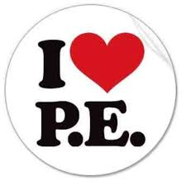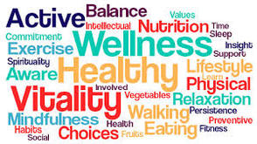
Philosophy:

Our physical & health education program is designed to assist students in acquiring the skills, knowledge, and attitudes which will help them attain an active healthy lifestyle and develop their potential; physically, intellectually, emotionally, and socially.

Objectives:

To assist students in obtaining and maintaining:
- health and fitness
- knowledge and motor abilities
- understanding of the human body, movement principles, and sport strategies
- positive attitudes towards themselves, others, and participation in various activities

STUDENT EXPECTATIONS

Attendance

You are expected to attend all classes and be on time. If illness occurs which prevents participation or causes absence, a note from parents/guardians explaining the absence is required. Excused students are expected to help out in class where possible, and remain with the class until the end of the period. A doctors note is required for any medical exemption preventing participation in excess of one week. It is the students’ responsibility to make up any missed learning or testing immediately upon their return to class.

Gym Strip

You are expected to bring and wear full gym strip (shorts, track pants, tights, t-shirt, sweatshirt, sport socks, and supportive athletic shoes). Be prepared to go outdoors (ie hoody), and it is strongly encouraged that students change for PHE, as they will be getting their sweat on. An additional lock is required to lock up your personal items during class time only. Please do not bring any valuables to class, as there have been many locker break-ins.
Participation

This is an active participation course! You are expected to participate in every activity to the best of your ability. You are expected to help and encourage classmates whenever possible, as well as assisting with the setting up and taking down of equipment.

Safety and Cooperation

Coduct yourself with an awareness of safety for you and others. Refrain from wearing jewelry and chewing gum. Follow all of the safety rules given by your teacher. Cooperate with classmates and teachers so that fun, participation, and learning can be enhanced.

EVALUATION

Personal & Social Responsibility |  |  |  |  | Attendance, Leadership, | 30%
 |  |  |  |  | P.E. Strip, Participation, Effort, Behaviour, Cooperation, Respectful to teacher and classmates
Physical Fitness & Training |  |  |  |  | Fitness testing and timed runs | 30%
Skill Development & Improvement |  |  |  |  | Skill acquisition, game play, performance and improvement | 30%
Theoretical Physical & Health Education Learning |  |  |  |  | Health and wellness assignments, written quizzes | 10%

