Ms. Inch Templeton Secondary kinch@vsb.bc.ca Main Gym

Welcome to Physical Education!
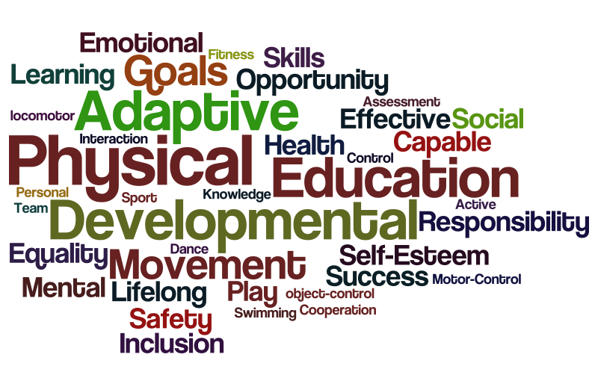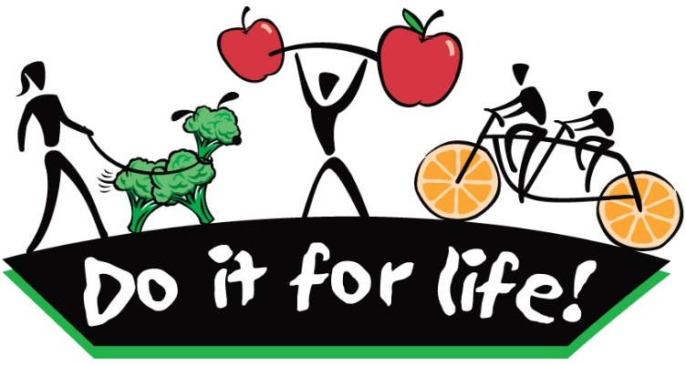
Dear parents or guardian of _____________________________:
Your child is currently enrolled in Physical Education (8, 9, or 10). This course is designed to assist students in acquiring the skills, knowledge, and attitudes which will help them attain a healthy lifestyle and develop their potential; physically, intellectually, emotionally and socially.
Throughout the course, your son/daughter will engage in a variety of learning activities including team and individual skill development, personal fitness endeavors, and participation in individual and team sports/games. These lessons are designed to promote health and fitness, develop movement concepts, improve knowledge of motor skills, encourage active participation and leadership, and foster an environment of positive self-esteem.
To benefit from Physical Education, students must actively participate in the learning process and work to develop their appreciation of health, fitness and wellness. These are the expectations for successful completion of PE:
- Students must be in regular attendance (this is a skill development and participation-based course).
- Student must have PE strip (appropriate footwear and clothing required - lockers provided. Changing for PE is recommended)
- Students must write all quizzes and complete assignments (it is the student’s responsibility to make these up immediately upon return).
- Students to engage in cooperative, supportive, and respectful behaviour to create the best possible learning and physical activity environment for everyone

More information can be found in the PE course outline. A copy can be accessed through our class website at http://msinch.weebly.com. This website will be updated on a regular basis and will provide important class information and access to other resources. If you need to get a hold of me you may reach me by email (kinch@vsb.bc.ca) or by phoning the school at 604-713-8984. Additionally, you can provide your current email address so I can send you progress reports as needed.

Parent name and phone number: _______________________________________
Parent email address: _________________________________________________
I hope this will be a great semester and I wish your son/daughter a great year of learning ahead!
____________________________ _____________________________
Student Signature Parent Signature
OVER…
Physical Education – Strengths & Goals for My Year

Welcome to Physical Education!
Please take some time to answer the following questions and reflect on your health, fitness & wellness.

- What are some of the things you enjoy most about PE class?

- What are some of the things you would like to see incorporated in PE class?

- What are some of your strengths in PE (including all aspects of health, wellness, fitness & recreation)?

- List at least 3 goals you would like to set for yourself this year in PE

- What has your result/mark been in PE in the past?

- What result/mark do you hope to achieve this year?

- What are some of the strategies you will use to achieve your goals in PE (specific things you will do to get there)?

- Other information and/or reflections?

